EENG 385 - Electronic Devices and Circuits

Frequency Domain: FFT and Fourier Series

Lab Handout

# Outcome and Objectives

The outcome of this lab is to comparison of the theoretical and measure frequency composition of a square wave. Through this process you will achieve the following learning objectives:

* Use a software tool to perform time and frequency domain analysis of an electronic circuit.
* Use laboratory test and measurement equipment to analyze electronic circuits.

# Fast Fourier Transform/ Fourier Series:

Most modern oscilloscopes have a fast Fourier transform (FFT) capability. A FFT is a graph of power vs. frequency for one of input channels of the oscilloscope. In other words, the oscilloscope decomposes the input waveform into that waveform’s constituent sine waves (using the fast Fourier transform) and then plots the magnitude of each of these sine wave at their respective frequency.

Figure 1 shows the FFT of a 1kHz square wave applied to channel 1 of the oscilloscope. The horizontal axis is scaled at 2kHz per division. The vertical axis is the voltage of the sin wave component at that frequency. The vertical axis is scaled at 1V RMS per division with 0V indicated by the grey “FFT” arrow on the left margin of the screen.

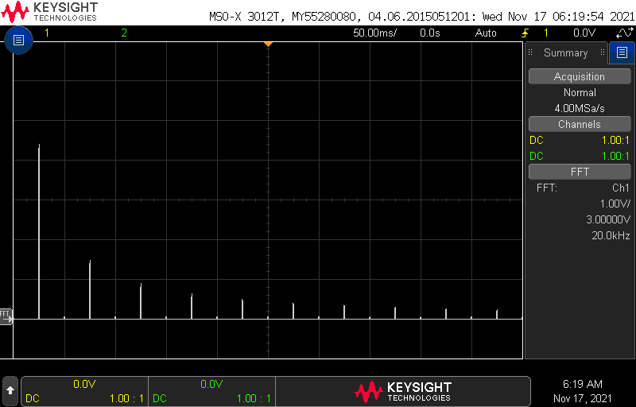

Figure : The FFT of a 1kHz square wave showing the Fourier series harmonics. The horizontal scale is 2kHz/division.

A close examination of the FFT in Figure 1 reveals a spike half way to the first vertical division, at 1kHz, that extends about 4.4 vertical division. This spike represents the energy of the 1kHz sine wave component of the square wave. The other sinusoidal components of the square wave show up as spikes at 3kHz, 5kHz, etc. In order to look at the FFT of a square wave let’s use a new piece of equipment in the lab, the BNC/BNC cable. This is just a cable with a BNC connector on each end shown in Figure 2.

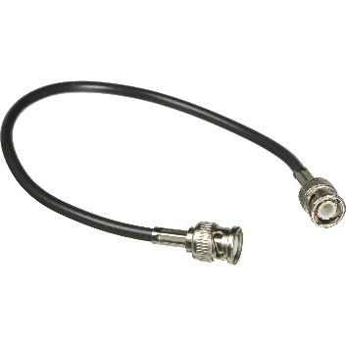

Figure : A BNC to BNC cable.

Configure you oscilloscope and function generator to look at the FFT of a square wave using the following procedure:

* Turn on the function generator and oscilloscope,
* Attach one end of the BNC/BNC cable to oscilloscope Ch1 and the other end to CH1 of the function generator,

Configure your function generator as follows:

* Waveform: Square
* Frequency: 1.0kHz
* Amplitude: 10.0V
* Offset: 0V

Configure Ch1 of the oscilloscope as follows:

|  |  |
| --- | --- |
| Horizontal (scale) | 1ms |
| Ch1 | BNC/BNC to CH1 of function generator |
| Ch1 (scale) | 5V/div |
| Ch1 (coupling) | DC |
| Trigger source | 1 |
| Trigger slope | ↑ |
| Trigger level | 0V |

You should see the square wave on the screen as expected. If present, remove Ch2 from the oscilloscope display by pressing the illuminated "2" button twice.

Add the FFT to the scope using the following instructions:

* [FFT] → Source: → 1
* [FFT] → Span → 20kHz
* [FFT] → Center: 10kHz
* [FFT] → More FFT
* [FFT] → Vertical Units→ V RMS
* [↑ Back] [↑ Back]
* Change the Horizontal scale from 1ms to 50ms. Note how FFT peak narrow.
* Remove the Channel 1 trace by pressing the illuminated “1” twice. Note, the waveform does not need to be present for the FFT function to work,
* Use the knobs to the right of the FFT button to
  + FFT scale 1V/
  + FFT offset 3V

You should see an image identical to Figure 1. Since we have configured the FFT for a span of 20kHz, each of the 10 horizontal divisions on the oscilloscope is 2kHz wide. The Fourier series allows you to represent a 0V–centered square wave with frequency ω0 and a 50% duty cycle as the sum of sinusoids using the Equation 1. Each of the cosine terms is called a harmonic with the n=1 term, $cos⁡(ω_{0})$ term being called the fundamental.

Equation : The Fourier series for a 50% duty cycle square wave centered at 0V.

$$\sum_{n odd}{\frac{1}{n}cos⁡(nω_{0})}$$

Note that Equation 1 does not contain any even harmonics. In other words, the coefficients of the $cos⁡(nω_{0})$ terms with n even, are 0 – this is why there are no spikes at 2kHz, 4kHz, … in Figure 1.

To see how the Fourier series relates to the FFT, let’s measure the height of the spikes in the FFT of a square wave and compare them to the coefficients in Equation 1. First, let’s calculate the coefficients of the various cos(ω0) terms of Equation 1 and put them into the “Theory” row in Table 1. That is compute $\frac{1}{n}$ for each value of n in the theory row.

Table : The magnitude of the various components of a square wave with f0=1kHz or, equivalently, ω0=6.28kRad/sec.

|  |  |  |  |  |  |
| --- | --- | --- | --- | --- | --- |
| n | 1 | 3 | 5 | 7 | 9 |
| nω0 | 1kHz | 3kHz | 5kHz | 7kHz | 9kHz |
| Theory | 1.0 | 0.33 | 0.2 | 0.14 | 0.11 |
| Measured | 4.4 | 1.5 | 0.9 | 0.65 | 0.5 |
| Scaled | 1 | 0.34 | 0.2 | 0.15 | 0.11 |

Now directly measure the amplitude of each sin wave using the information from the oscilloscopes’ FFT. However, instead of measuring the height of each peak and recording it in Table 1, let’s have the oscilloscope measure the heights of the different peaks. To do this, you will have to find the Search button, it’s located near the top center of the oscilloscope. Now that you’ve found it, configure your oscilloscope as follows:

* [Search] → Search: → Frequency Peaks
* [Search] → Max #Peaks: → 5
* [Search] → Max #Peaks: → 5
* [Search] → Threshold→ 100mV
* [Search] → Excursion→ 100mV
* [Search] → Results Order→ Freq Order
* [↑ Back]

You should see something similar to Figure 3.

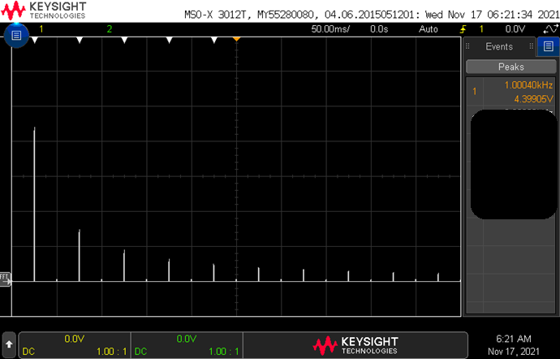

Figure : The FFT of a 1kHz square wave with information about the magnitude of the peaks.

According to the data presented by the oscilloscope in Figure 3, the 1kHz component of the 10V square wave has an amplitude of 4.4V RMS. Look at the data from your oscilloscope and put the corresponding magnitude of your 1kHz sinusoidal component in the Mag row of Table 1 under the 1kHz column. Continue to fill in the remaining magnitudes at higher frequencies.

In order to compare the values that you just filled in with the theoretical value from Equation 1, you need to scale all the measured amplitudes down so that the 1kHz amplitude is 1V. Do this by dividing each entry in the Measured row by the 1kHz measured voltage. This will normalize the measured voltages to a 1V to 0V scale, the same as the voltages in the theory row.

# Turn in:

Make a record of your response to numbered items below and turn them in a single copy as your team’s solution on Canvas using the instructions posted there. Include the names of both team members at the top of your solutions. Use complete English sentences to introduce what each of the following listed items (below) is and how it was derived.

**Fast Fourier Transform/ Fourier Series**

* Table 1